Massage Intake Form

Personal Information
Name
Address

Phone (day) (evening)
City/State/Zip DOB

Occupation Employer
Email Primary Physician
Emergency Contact Relationship Phone
How did you hear about us?

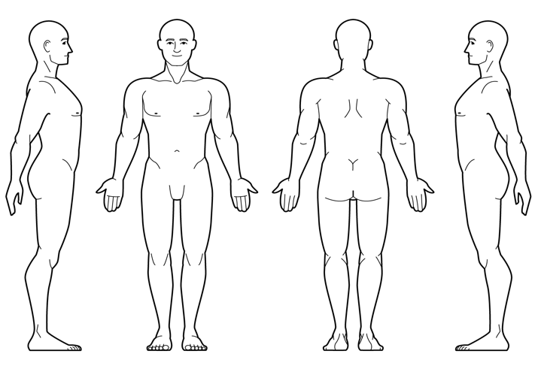Medical Information Massage Information

Are you taking any medications? ☐ yes ☐ no
If yes, please list name and use: _ __ __ __ ______
______________________________________ __ ___ Are you currently pregnant? ☐ yes ☐ no
If yes, how far along? __ __ __ _____________ _
Any high risk factors? _ __ __ __ __ __ _______
Do you suffer from chronic pain? ☐ yes ☐ no
If yes, please explain __ __ __ __ __ ________
What makes it better? __ __ __ __ __ _______
__________________________________________ ___ What makes it worse? __ __ __ __ _ _______
______________________ __ __ __ __ __ ___ Have you had any orthopedic injuries? ☐ yes ☐ no
If yes, please list: __ _ __ __ __ __ _______
Please indicate any of the following that apply to you.
Have you had a professional massage before? ☐ yes ☐ no What type of massage are you seeking?
- Relaxation ☐ Therapeutic/Deep Tissue Other ___ __ _ __ __ __ __ __ ___________
What pressure do you prefer?
- Light ☐ Medium ☐ Deep
Do you have any allergies or sensitivities? ☐ yes ☐ no Please explain __ __ __ __ __ __ ________
Are there any areas (feet, face, abdomen, etc.) you do not want massaged? ☐ yes ☐ no
Please explain __ __ __ __ __ __ _____
What are your goals for this treatment session?
__ __ __ __ __ __ __ __ ___________ Please circle any areas of discomfort

- Cancer
- Headaches/Migraines
- Arthritis
- Diabetes
- Joint Replacement(s)
- High/Low Blood Pressure
- Neuropathy
- Fibromyalgia
- Stroke
- Heart Attack
- Kidney Dysfunction
- Blood Clots
- Numbness
- Sprains or Strains

Explain any conditions you have marked above:
__ __ __ __ __ __ __ __ __ __ __ __
__ __ __ __ __ __ __ __ __ __ __ __
__ __ __ __ __ __ __ __ __ __ __ __
__ __ __ __ __ __ __ __ __ __ __ __

I understand that the massage I receive is provided for the basic purpose of relaxation and relief of muscular tension. If I experience any pain or discomfort during the session, I will immediately inform the therapist so that the pressure and/or strokes may be adjusted to my level of comfort. I further understand that massage should not be construed as a substitute for medical examination, diagnosis, or treatment. I understand that massage therapists are not qualified to perform spinal or skeletal adjustments, diagnose, prescribe, or treat any physical or mental illness, and that nothing said in the course of the session given should be construed as such. Because massage should not be performed under certain medical conditions, I affirm that I have stated all my known medical conditions and answered all questions honestly. I agree to keep the massage therapist updated as to any changes in my medical profile during the session and understand that there shall be no liability on the massage therapists’ part should I fail to do so. I understand that any illicit or sexually suggestive remarks or advances made by me will result in immediate termination of the session. I also understand that the Massage Therapist reserves the right to refuse to perform massage on anyone whom he/she deems to have a condition for which massage is contraindicated.

I have completed this form to the best of my ability and knowledge and agree to inform my therapist if any of the above information changes at any time.

Client Signature _ __ __ _______________ Date _____ ___

Therapist Signature ___ _ __ __ __ ___ Date __________

